QUESTIONS: 5 Duration : 1 Hour
Total Marks:50

Annexure A
Analytical Problem Solving

Code of Conduct:
I __________P.Sai Swetha(192324011)__________ (Name / Reg No) certify that this submission is my original work
and that I have adhered to the guidelines specified for this assessment.
I understand that any violation of academic integrity rules will result in disciplinary action.
Signature of the student:
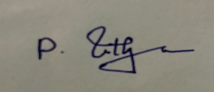
Annexure A
Analytical Problem Solving

1. Solve the Water Jug problem: you are given 2 jugs, a 4-gallon one and 3-gallon one.
Neither has any measuring maker on it. There is a pump that can be used to fill the
jugs with water. How can you get exactly 2 gallons of water into 4-gallon jug?
Explicit assumptions: A jug can be filled from the pump, water can be poured out of a
jug onto the ground, water can be poured from one jug to another and that there are
no other measuring devices available.
2. Find out how Mars Rover, analyse and explore the samples on Mars by answering the
following questions.
i. What are the percept’s for this agent?
ii. Characterize the operating environment.
iii. What are the actions the agent can take?
iv. How can one evaluate the performance of the agent?
v. What sort of agent architecture do you think is most suitable for this agent?
Why?

3. Explore the search space using search strategies and formulate the problem
components for the 8-Queens problem using the following information: Place 8
queens on a chessboard such that none of the queen’s attack any of the others. A
configuration of 8 queens on the board as shown in the figure below, but this does not
represent a solution as the queen in the first column is on the same diagonal as the
queen in the last column.
4. A customer wants to travel from the one location to another location using OLA Cab
booking mobile application. The customer can select the any of the cab type as mini,
micro, sedan, shared, prime and so on based on his comfort to reach the destination.
Identify what type of problem-solving agent can be used and write the pseudocode
for the above problem.
5. A logistics company operates a delivery network where packages must be transported
between warehouses at minimum cost. Each route between warehouses has an
associated travel cost (fuel + time). The company wants to determine the least-cost
path from the starting warehouse S to the destination warehouse G using the Uniform
Cost Search (UCS) algorithm.
The delivery network is represented as a weighted graph:

CSA1715 – ARTIFICIAL INTELLIGENCE
Analytical Problem Solving
P.SAI SWETHA
192324011
1 Problem
Measure exactly 2 gallons in the 4-gallon jug using only a 4-gallon jug, a 3-gallon jug, and a water pump.
Solution Steps
Step | 4-Gallon Jug | 3-Gallon Jug | Action
1 | 0 | 3 | Fill the 3-gallon jug.
2 | 3 | 0 | Pour all water into the 4-gallon jug.
3 | 3 | 3 | Fill the 3-gallon jug again.
4 | 4 | 2 | Pour water into the 4-gallon jug until it is full. Only 1 gallon is needed, leaving 2 gallons in the 3-gallon jug.
5 | 0 | 2 | Empty the 4-gallon jug.
6 | 2 | 0 | Pour the remaining 2 gallons from the 3-gallon jug into the 4-gallon jug.
Answer
The 4-gallon jug now contains exactly 2 gallons of water.

2 Problem

Mars Rover Agent
(i) Percepts
The rover perceives:
- Camera images
- Rocks and soil
- Temperature
- Obstacles
- Terrain
- GPS/location
- Battery level
- Sensor readings

(ii) Operating Environment
- Partially Observable
- Dynamic
- Sequential
- Stochastic
- Continuous
- Single Agent

(iii) Actions
- Move forward/backward
- Turn left/right
- Avoid obstacles
- Collect soil samples
- Analyze rocks
- Capture images
- Send data to Earth
- Recharge using solar panels

(iv) Performance Measure
Performance is evaluated by
- Number of samples collected
- Accuracy of analysis
- Distance covered
- Energy efficiency
- Successful communication
- Safety of rover
- Completion of mission

(v) Suitable Agent Architecture
Utility-Based Learning Agent
- Makes decisions based on battery life.
- Learns from previous observations.
- Chooses the safest and shortest path.
- Optimizes mission success.

3 Problem

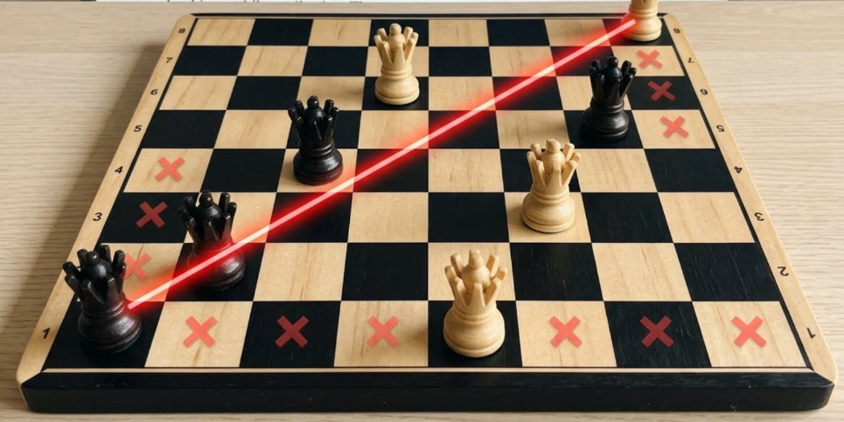

8-Queens Problem
Problem Components
Initial State
Empty 8×8 chessboard.

State Space
All possible arrangements of 8 queens.

Successor Function
Place one queen in the next column ensuring no attack.

Goal Test
No two queens attack each other.
- No same row
- No same column
- No same diagonal

Path Cost
Every move has equal cost.

Search Strategy
Backtracking Search (Depth-First Search)

Solution Representation
One valid solution is
Column | 1 | 2 | 3 | 4 | 5 | 6 | 7 | 8
Row | 1 | 5 | 8 | 6 | 3 | 7 | 2 | 4
No queens attack each other.

4 Problem

OLA Cab Booking Application
Suitable Problem Solving Agent
Goal-Based Agent
Reason:
The goal is to reach the destination while selecting the preferred cab type.

Pseudocode
START

Input source
Input destination

Display cab types
(Mini, Micro, Sedan, Prime, Shared)

User selects cab

Calculate distance

Estimate fare

Show estimated arrival time

Ask for confirmation

IF confirmed THEN
Book cab
Assign nearest driver
Send booking details
ELSE
Cancel booking
ENDIF

END

5 Problem

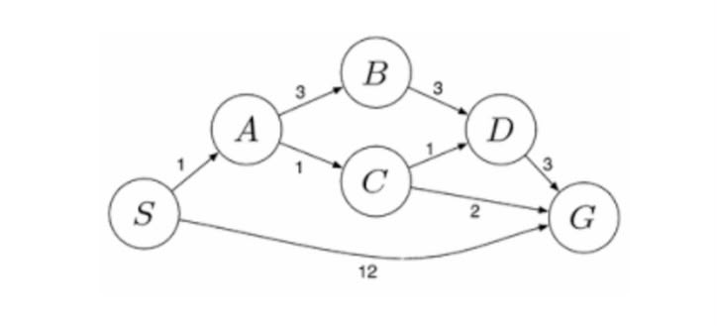

Uniform Cost Search (UCS)
Graph
Edges:
S → A = 1
S → G = 12
A → B = 3
A → C = 1
B → D = 3
C → D = 1
C → G = 2
D → G = 3

UCS Steps
Step | Node Expanded | Cost
1 | S | 0
2 | A | 1
3 | C | 2
4 | D | 3
5 | G | 4

Path Costs
- S → G = 12
- S → A → B → D → G = 10
- S → A → C → D → G = 6
- S → A → C → G = 4 (Minimum Cost)

Final Answer
Least Cost Path:
$$\boxed{S→A→C→G}$$
Total Cost:
$$\boxed{1+1+2=4}$$

